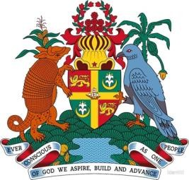

REQUEST FOR BIRTH CERTIFICATE

AFTER NAME CHANGE ON AFFIDAVIT
The following form needs to be completed in its entirety in order to apply for an updated Birth Certificate after a name change through an Affidavit. Please include Affidavit with this request.

Applicant’s First Name | Applicant’s Middle Name(s) |  |  | Applicant’s Last Name |  | Applicant’s Maiden Name*
Applicant’s Date of Birth (dd/mm/yyyy) |  |  | Applicant’s Place of Birth (Parish)
Applicant’s Cellular No. |  |  | Applicant’s E–Mail Address
Mother’s First Name |  | Mother’s Middle Name(s) |  |  | Mother’s Maiden Name
Mother’s Date of Birth (dd/mm/yyyy) |  |  |  | Mother’s Place of Birth (Parish)
Fee – US$7.00 (Money Order for US$5.00 and US$2.00 cash for the stamps) |  |  |  | Return Address:
The Consulate General of Grenada in Miami will facilitate forwarding this request to the Registrar’s Office (473–440–2806), through the Immigration and Passport Department (IPD). Packages are forwarded to the IPD every Friday.

FORWARD APPLICATION AND FEE TO:
CONSULATE GENERAL OF GRENADA

11900 Biscayne Boulevard
Suite 740
North Miami, FL 33181–2733

Tel. (305) 570–2716 x.102
WhatsApp (305) 465–1957

* If Applicable

